**Sahib Nijjar**

**INFO 1113, S10**

**November 12, 2019**

<https://github.com/Nijjar47/Project/blob/master/FINALUSECASE.PNG>

<https://sites.google.com/view/info1112-project-2019/home>

**My Original Use Case Diagram**

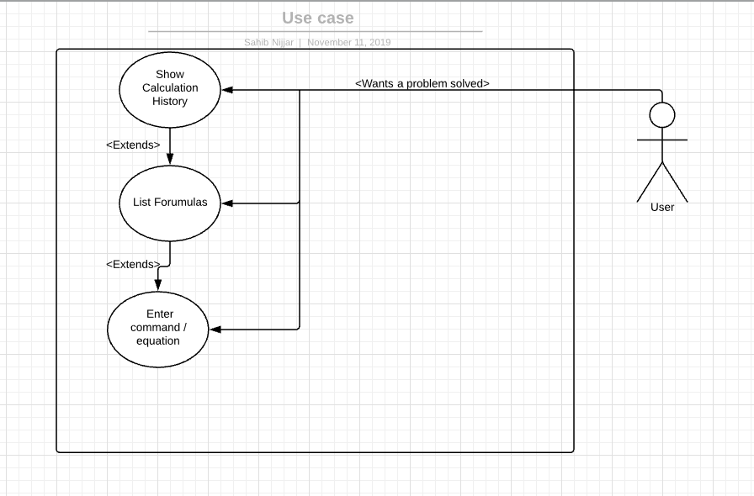

This picture above is my original use case diagram that each group member had to create. Mine consisted of 3 uses, show calculation history, list formulae, and enter command/equation.

**Final Use Case Diagram**

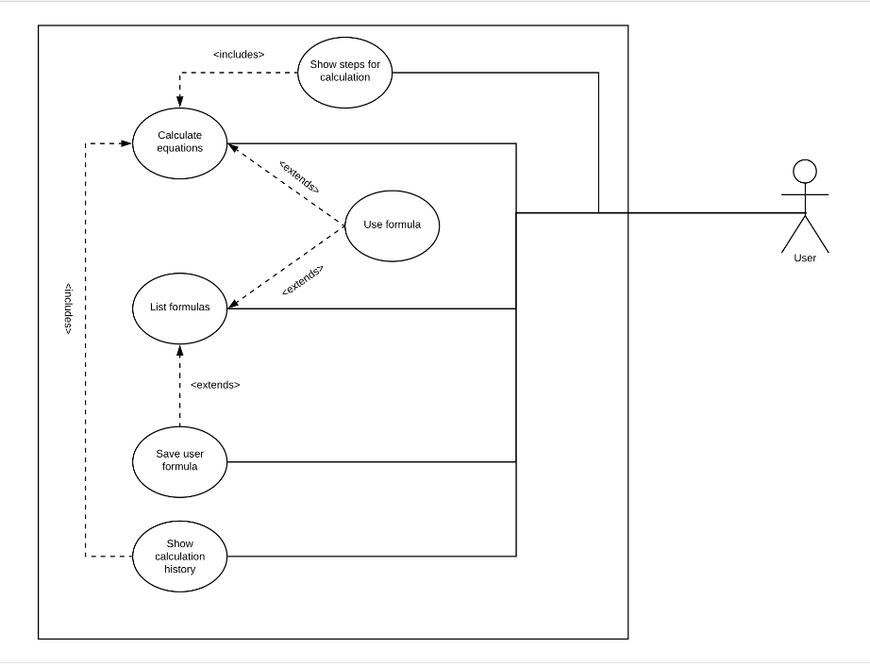

|  |
| --- |
| Use Case Title: Show Calculation History |
| Primary Actor: User |
| Stakeholders: User |
| Precondition: User must have had calculations already done previously |
| Minimal guarantee: Error message, main screen |
| Success guarantee: Previously used calculations |
| Trigger: User clicks corresponding button using mouse |
| Main Success Scenario:   1. User previously has entered in a calculation (eg: 2 + 4 = 6). 2. At main menu, User clicks “Show Calculation History”. 3. Program displays previously entered calculation. |
| Extensions:   1. Error message displayed.    1. Program explains to the user that no calculation has been done, prompted to enter in a calculation. |
|  |

|  |
| --- |
| Use Case title: List Formulae |
| Primary actor: User |
| Stakeholders: User |
| Precondition: User has formula(s) saved from previous equations |
| Minimal Guarantee: Error Message |
| Success Gaurantee: displays formulae used from previous equations |
| Trigger: User clicks “List Formulae” button on screen using mouse |
| Main success scenario:   1. User clicks “List Formulae” 2. Program lists all previously used formulae |
| Extensions:   1. Error message displays    1. User gets told that no formulae have been saved, and gets prompted to enter an equation. |

|  |
| --- |
| Use Case Title: Save user formula |
| Primary Actor: User |
| Stakeholders: User |
| Precondition:   1. Program running / At main menu 2. User is in the middle of an equation, prompted to save used formula anytime |
| Minimal Guarantee: Error message |
| Success Guarantee: User saves formula and has been entered into the saved files |
| Trigger:   1. User selects “Save user formula” button on main menu, and can enter a formula he/she wishes to save. 2. User selects “Save used formula” while performing an equation, can be saved into files. |
| Main success scenario:   1. User clicks “Save user Formula” button on main screen    1. User enters formula    2. User saves formula 2. User enters an equation   2.1) User clicks “Saved used formula”  2.2) Formula used gets saved into files |
| Extensions:   1. Error message displayed    1. User gets told that no formula has been entered to save    2. Program prompts user to enter a formula that he/she wishes to save |